

**GENERAL MEETING**

**INTERNATIONAL FORUM FOR INSURANCE GUARANTEE SCHEMES**

**May 26th and 27th, 2015**

**Hosted by Consorcio de Compensación de Seguros**

**Madrid, Spain**

**___________________________________________________________**

**REGISTRATION FORM**

Family Name: **________________________________________________________**

First Name: **__________________________________________________________**

Title: **_______________________________________________________________**

Institution: **___________________________________________________________**

Email: **_____________________________**Phone: ( ) **______________**ext.**______**

Companion? ___ yes ____ no

Please indicate any dietary requests:

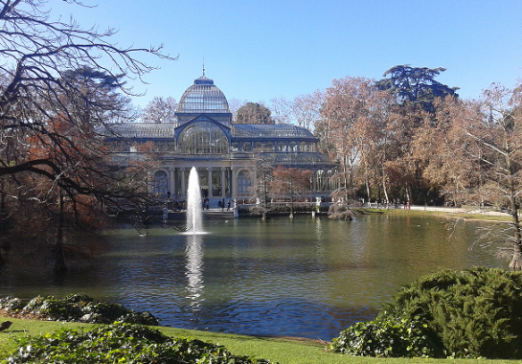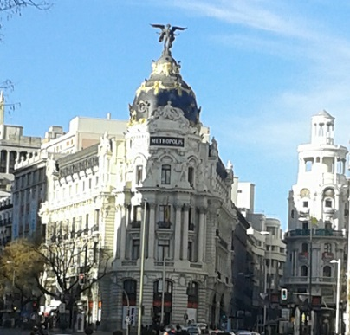

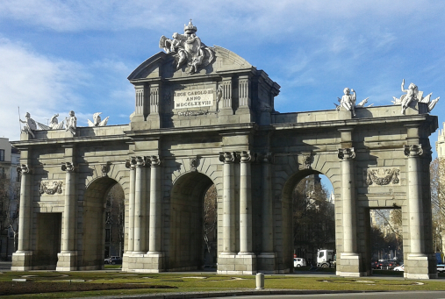

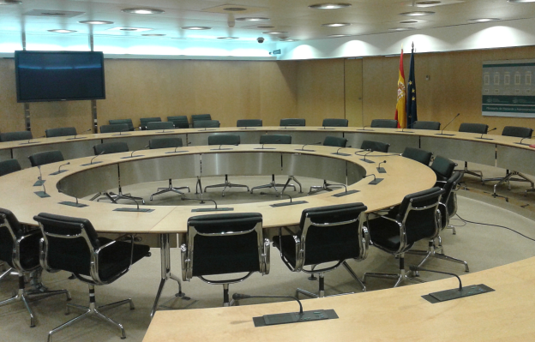

**Meeting Room:**

Room B – 2nd floor

Ministry of Economy and Competitiveness

Paseo de la Castellana, 162   
Madrid 28046 -Spain

**ADDITIONAL INFORMATION**

Transportation to and from the airport to the hotel is the responsibility of each attendee. The taxi fare (from or to the airport) is 30 € per trip. This flat price includes baggage.

To be registered to attend this event, please complete and return this form by **September 30, 2011**.

Please, complete and return these two pages to the Section for Studies and International Relations of the Consorcio de Compensación de Seguros, by 15 April 2015.

E-mail: estudiosrrii@consorseguros.es

Phone: + 34 91 339 56 89

Thank you for your participation. We look forward to meeting you in Toronto.

**ACCOMODATION:** Please, find the hotel references at the next page.

*Please use block letters and read the programme and general information before completing the form:*

*Convention Team. Avenida de Cantabria, 51 28042 Madrid. Telephone Number: +34 91 454 60 14*

*Please, send this form by Fax:+34 91 559 47 89, or E-mail:* [*grupossectorpublico@viajeseci.es*](mailto:grupossectorpublico@viajeseci.es)

**

|  |  |  |  |  |  |  |  |  |  |  |  |  |  |  |  |
| --- | --- | --- | --- | --- | --- | --- | --- | --- | --- | --- | --- | --- | --- | --- | --- |
| **PERSONAL DATA** | | | | | | | | | | | | | | | |
| **Family Name** | |  | | | | | | **First Name** | |  | | | | | |
| **Organization** | | | | |  | | | | | | | | | | |
| **Addres** | | |  | | | | | | | | | | | | |
| **Postal Code** | | | |  | | **City** |  | | | | | **Country** | |  | |
| **E-mail** |  | | | | | | | | **Phone** | |  | | **Fax** | |  |

|  |  |  |  |  |  |  |
| --- | --- | --- | --- | --- | --- | --- |
| **BOOKINGS. Please, Check and fill in the form for 25th to 28th nights and we will do your reservation if you wish:** | | | | | | |
| **CATEGORY** | **OFFICIAL HOTELS** | **ROOMS *(Price/day for 1 ó 2 persons)*** | | | | |
| 5***** | Hotel HESPERIA MADRID | Individual | 195.8 Eur | Double | 212.3 Eur | |
| 5***** | Hotel MELIÁ CASTILLA | Individual | 159.5 Eur | Double | | 170.5 Eur |
| 5***** | Hotel MIGUEL ÁNGEL | Individual | 121 Eur | Double | 132 Eur | |
| 4**** Sup. | Hotel NH EUROBUILDING | Individual | 176 Eur | Double | 192.5 Eur | |
| 4**** | Hotel AC AITANA | Individual | 132 Eur | Double | | 145.2 Eur |

**Price / day, in single room or double room for 2 persons. Including breakfast and VAT.**

|  |  |  |  |  |  |  |  |  |
| --- | --- | --- | --- | --- | --- | --- | --- | --- |
| **Arrival Date** |  | **Departure Date** |  | **Nights** |  | | | |
| **Persons** |  | **Room** |  |  |  |  |  |
|  |  |  |  |  |  |  |  |
|  |  |  |  | **Total Amount** |  | | | |

**FORM OF PAYMENT**

* **Bank Transfer:**

**Bank Transfer inside Spain:**  **Bank Transfer outside Spain:**

Bank Santander BBVA

Plaza Canalejas, 1 - 28014 Madrid CC: 0182 3999 37 0200664662

cc: ES37 0049 1500 03 2810355229 IBAN Code: ES970182

SWIFT Code: BB VAESMMXXX

**\*\* Time limit to submit the registration: 1 st May. After this date will not be guaranteed the rooms, which will be under AVAILABILITY at the time of booking.**

**\*\* For days before and after, availability and rates will be on request.  
Important Note**: You must complete the form properly, and if you make a bank transfer, please send us the bank receipt by fax +34 91 559 47 89 or by mail.  
In case of cancellation, please let us know by 06 May 2015. After this date you may have cancellation fees.